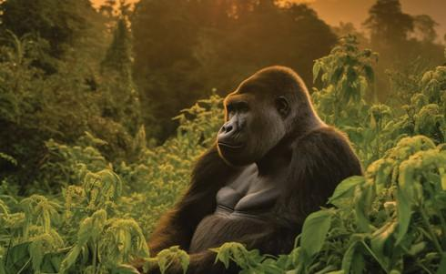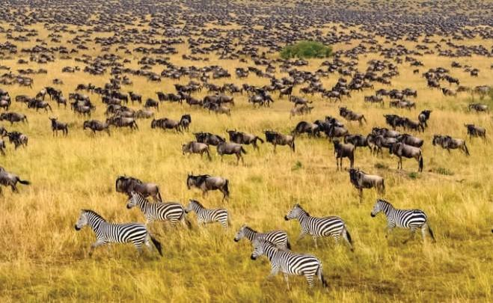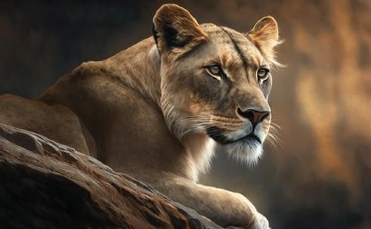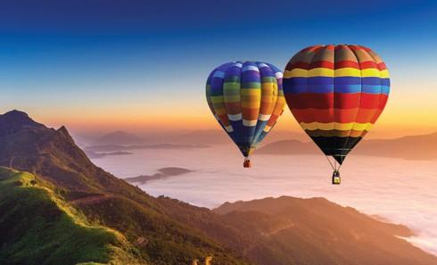

UGANDA

EXPERIENCE UGANDA - 9 DAYS

We truly appreciate your keen interest in embarking on an extraordinary African adventure with us. It fills us with great enthusiasm to be part of your journey as we create unforgettable memories amidst the breathtaking splendors of Uganda.

At Tilenga Safaris, our mission is to craft the perfect bespoke adventures and safaris across this magnificent continent we are proud to call home. With a deep passion for Africa’s natural beauty and cultural richness, we are dedicated to delivering exceptional, personalized experiences that go beyond the ordinary.

Travel Highlights
- Lake Mburo National Park
- Bwindi Impenetrable National Park
- Chimpanzee Tracking
- Gorilla Tracking
- Queen Elizabeth National Park
- Game Drives
- Cultural Experiences
- Murchison Falls National Park

The ultimate safari experience in Uganda begins and ends at Entebbe International Airport. Your journey unfolds with breathtaking encounters from the awe-inspiring Big Four and a serene safari boat ride, to world-class birding, witnessing the thundering power of Murchison Falls, and meeting the gentle giants during an unforgettable Gorilla Trekking adventure.

This 9-day safari takes you across Uganda’s Western, Northern, and Central regions, offering a perfect blend of wildlife, culture, and scenic beauty. Enjoy luxurious accommodations at handpicked lodges, expert guidance from professional safari guides, and delicious en-route meals, all thoughtfully arranged to make your journey truly exceptional.

DETAILED ITINERARY
DAY 1: LAKE MBURO NATIONAL PARK
On arrival at Entebbe International Airport in Uganda, you will be met by a Tilenga Safaris representative and guide. They will be waiting for you, holding a placard with your name on it, on your way out after clearing with immigration.
The guide will assist you with your luggage and drive you to have breakfast in Entebbe before you begin your journey to Lake Mburo National Park.
Your journey to Kiruhura district will begin here, as you’re transferred to Lake Mburo National Park (Approximately 6 hours' drive from Entebbe). On arrival, you will check in, have lunch, and get ready for a nature walk/ walking safari tour in the park, and while here, you will have a clear and close view of Zebras, antelopes, buffalo, bushbucks, and many more. Your tour will be guided by a wildlife ranger who knows the best spots of the park with the best views. Of course, it is not entirely flat terrain, so expect some hilly and sloppy places, but on the whole, the tour is an amazing experience.

Main Destination: Lake Mburo National Park
Accommodation:5★ Kigambira Safari Lodge | 4★ Mihingo Lodge | 3★ Kigarama Wilderness Lodge
Meals and drinks: Full Board

DAY 2: TRANSFER TO BWINDI IMPENETRABLE NATIONAL PARK
The day begins with breakfast at the lodge, then have a short game drive in Lake Mburo National Park, and right after the Journey to Kisoro begins. This is a 5-hour drive from Kiruhura District.
Bwindi Impenetrable National Park is the habitat of more than half the world’s population of Mountain Gorillas with over 300 mountain gorillas living here, 346 bird species, and 200 butterfly species.
The word “Bwindi” means “darkness” and taking a hike in this magnificent forest will certainly unveil to you the reason why the forest was named so. You will also be in a position to quickly tell why the forest is also regarded as Impenetrable. One is required to be physically fit to take part in this mountain gorilla tracking / trekking adventure because it may involve climbing steep terrain.
After check-in at the lodge where you will be staying, you will have some time to swim, relax, and then have dinner.
Main Destination: Bwindi Impenetrable National Park
Accommodation: 5★ Bwindi Lodge | 4★ Mahogany springs Lodge | 3★ Four Gorilla Lodge
Meals and drinks: Full Board

DAY 3: GORILLA TRACKING

Travelers say there is no other wildlife encounter in Africa that compares to the outstanding experience of spending face-to-face time with Uganda’s wild gorillas in a natural setting.
Seeing the sheer might yet gentleness of the silverbacks and the playful nature of the juveniles and infants is an unforgettable experience.

Gorilla treks begin at 8 AM every day with a briefing after which groups of a maximum of eight tourists trek into the mysterious jungle. The trek can last anywhere from 1 hour to 5 hours depending on where the gorilla families will be on a specific day and you will be led by expert rangers and an experienced team of advanced trackers.

There is also a pleasant opportunity to see several other fauna and flora species, and birding along the way. Which gorilla trekking section you should choose for your adventure excursion will depend on where the gorilla permit will be available when making reservations.

Later in the afternoon, you will then head out for an activity at Ride 4 A woman.
A Ride for a Woman in Bwindi Impenetrable National Park offers simple but meaningful activities that connect visitors with the local community. You can take a village walk, join the women in singing and dancing, and learn basic skills like basket weaving or cooking traditional food. The experience is relaxed and personal, giving you time to hear real stories and understand how the project supports women in building better lives. It’s a genuine way to engage with the culture while directly supporting the community.

Main Destination: Bwindi Impenetrable National Park
Accommodation: 5★ Bwindi Lodge | 4★ Mahogany springs Lodge | 3★ Four Gorilla Lodge
Meals and drinks: Full Board

DAY 4: TRANSFER TO QUEEN ELIZABETH NATIONAL PARK
Transfer from Kisoro – Bwindi Impenetrable National Park to Queen Elizabeth National Park (The second Largest Park in Uganda, named after the Late Queen Elizabeth II (RIP) and popularly known for Savannah grasslands and being home to the big cats, i.e., Lions, Leopards, etc., and Elephants too.

The park is home to 618 bird species, which is the 6th highest diversity in the world and the highest in Africa, making it a perfect destination for Birding, in addition to 10 primate species like chimpanzees and 95 mammals, including Big 4 (Lions, Leopards, buffalo, and Hippos)

Early morning breakfast, check out, and continue your safari in Queen Elizabeth National Park. On arrival in Kasese Queen Elizabeth National Park, you will check in, have a quick lunch, and then head out for a boat cruise safari.

An afternoon boat ride on the Kazinga Channel is a highlight of the safari in Queen Elizabeth National Park, and it will reward you with wonderful sightings of Hippos, Crocodiles, Monitor Lizards, Elephants, Buffaloes, and Antelopes, and by the water, trying to stay hydrated. And then return to the Lodge for Dinner and a night’s rest

Main Destination: Queen Elizabeth National Park
Accommodation: 5★ Kyambura Gorge Lodge | 4★ Elephant Plains Lodge | 3★ Kikorongo Safari Lodge
Meals and drinks: Full Board

DAY 5: TRANSFER TO KIBALE NATIONAL PARK FOR CHIMPANZEE TRACKING
After breakfast, you will head out for an Early morning Game drive in QENP, which is popularly known for its Savannah grasslands and is home to the big cats, i.e., Lions, Leopards, etc., and Elephants too. You will catch sight of mostly Lions, Leopards, and hyenas, which are the most common predators. Other animals include the Warthog, Buffalo, Elephant, Uganda Kob, Waterbuck, Oribi, Topi, and Giant Forest Hog.
After the Game drive, you will have an early lunch and then be transferred to Kibale Forest National Park for Chimpanzee tracking.
After checking in, you will continue for an afternoon visit to the Bigodi community. The Bigodi community walk is a walk through one of the most scenic areas and habitats of bird and mammal species. A 2-3 hour walk through the Bigodi swamp allows you to spot over 310 bird species, 5 different primates, and very beautiful flora.
The walk will take up to 2 to 3 hours, depending on the pace of the group. According to your interests, you will first visit a traditional healer who will happily share his knowledge about spirits, herbs, plants, and local medicines.
Then you will visit the homes of elderly men and women who tell interesting stories about birth, marriage, ceremonies, clans, and their traditional life. Learn more about the history and issues that they face as a developing community in rural Uganda. Along the way, you will also be given the chance to experience the Ugandan school system and visit a local church and Bigodi’s trading center, a hub of rural life and activity.
Main Destination: Kibale National Park
Accommodation: 5★ Kibale Lodge | 4★ Chimpundu Lodge | 3★ Isunga Safari Lodge
Meals and drinks: Full Board.

DAY 6: CHIMPANZEE TRACKING AND TRANSFER TO MURCHISON FALLS NATIONAL PARK.
Early morning Chimpanzee tracking and a scenic transfer to Queen Elizabeth National Park, and relaxation at the lodge.

During tracking, you will be able to see other primates and wildlife like the red-tailed monkeys, black and white colobus monkeys, and a variety of bird species, among others.
While it can be challenging to follow the lead of these agile primates, the experience is thoroughly rewarding.

In the afternoon, you will continue your journey to Murchison Falls with a stopover for a simple hike to the Top of Murchison Falls, where the Nile squeezes through an 8-metre-wide gorge and plunges with a thunderous roar into the “Devil's Cauldron creating a trademark rainbow.

Main Destination: Murchison Falls National Park
Accommodation: : 5★ Nile Safari Lodge | 4★ Entiko Safari Lodge | 3★ Tilenga Safari Lodge
Meals and drinks: Full Board

DAY 7: GAME DRIVE AND BOAT CRUISE ON THE NILE

An early morning game drive; while doing the game drive, expect to see Elephants, Giraffes, Lions, Warthogs, Uganda Kobs, Buffaloes, Waterbucks, and birding for some unique bird species in the wild. An early game drive to catch all animals before they go out to feed/hunt. This activity takes between 3- 4 hours as you view elephants, lions, giraffes, leopards, buffaloes, Kobs, etc. You will then return to the Lodge for lunch.

In the afternoon, go for a launch cruise on the Nile to the launch/bottom of the mighty Murchison Falls, 10 meters away from the Devil’s Cauldron. Along the banks of the Nile, you will come up close with Hippo Schools, large crocodiles. Elephants cooling off by the shores of the Nile, waterbucks, and some birds too, e.g., cormorants, and bee-eaters, among others. The launch cruise along the Nile will give you an exciting panoramic view at the bottom of Murchison Falls.

Main Destination: Murchison Falls National Park
Accommodation: : 5★ Nile Safari Lodge | 4★ Entiko Safari Lodge | 3★ Tilenga Safari Lodge
Meals and drinks: Full Board

DAY 8: TRANSFER TO KAMPALA

This is the last day in the wild. After having breakfast, you will check out and start your journey to Kampala. This is a 6 to 7-hour drive to Kampala.

On arrival in Kampala, you will check in at your hotel and then get ready to head out for a cultural show at Ndere Center. You will have a late dinner, and after dinner, rest for the day.

Main Destination: Kampala
Accommodation: : 5★ Kampala Serena Hotel | 4★ Four Points by Sheraton | 3★ Onomo Boutique Hotel
Meals and drinks: Full Board

DAY 9: DEPARTURE

This is the last day of your trip; after having breakfast, you will be transferred back to Entebbe International Airport to board to your preferred destination.

Main Destination: Entebbe International Airport
Meals and drinks: Breakfast

END OF TRIP.

TRIP COSTS – QUOTED IN USD

NO OF PAX | 1 | 2 | 3 | 4 | 5 | 6
COST PER PERSON – 3 STAR | 6456 | 4501 | 3981 | 3846 | 3843 | 3627
COST PER PERSON – 4 STAR | 10,485 | 7288 | 6840 | 6633 | 6879 | 6414
COST PER PERSON – 5 STAR | 20,077 | 15,802 | 15,055 | 15,071 | 15,487 | 14,827

What is Included:
- All Park fees
- All activities (Unless labeled as optional)
- All accommodation as per the options chosen
- A professional driver/guide
- All transportation in safari 4 X 4 vehicle with a pop-up roof
- All Taxes/VAT
- Roundtrip airport transfer
- Meals (As specified in the day-by-day section)
- Complementary bottle of water per day and simple travel snacks.

What is Excluded:
- Air tickets to international flights (From/to home)
- Visas
- Additional accommodation before and at the end of the tour
- Tips
- Personal items (Souvenirs, travel insurance, etc.)
- Government-imposed increase of taxes and/or park fees
- Drinks

